start by

Driver manager

driver manager is a class which is present in Java .SQL package which will provide the driver classes or particular database and it will create new driver classes according to our requirement.

Driver manager is the one of the important concept in JDBC API which will provide the registered driver class and register the driver class and get connection.

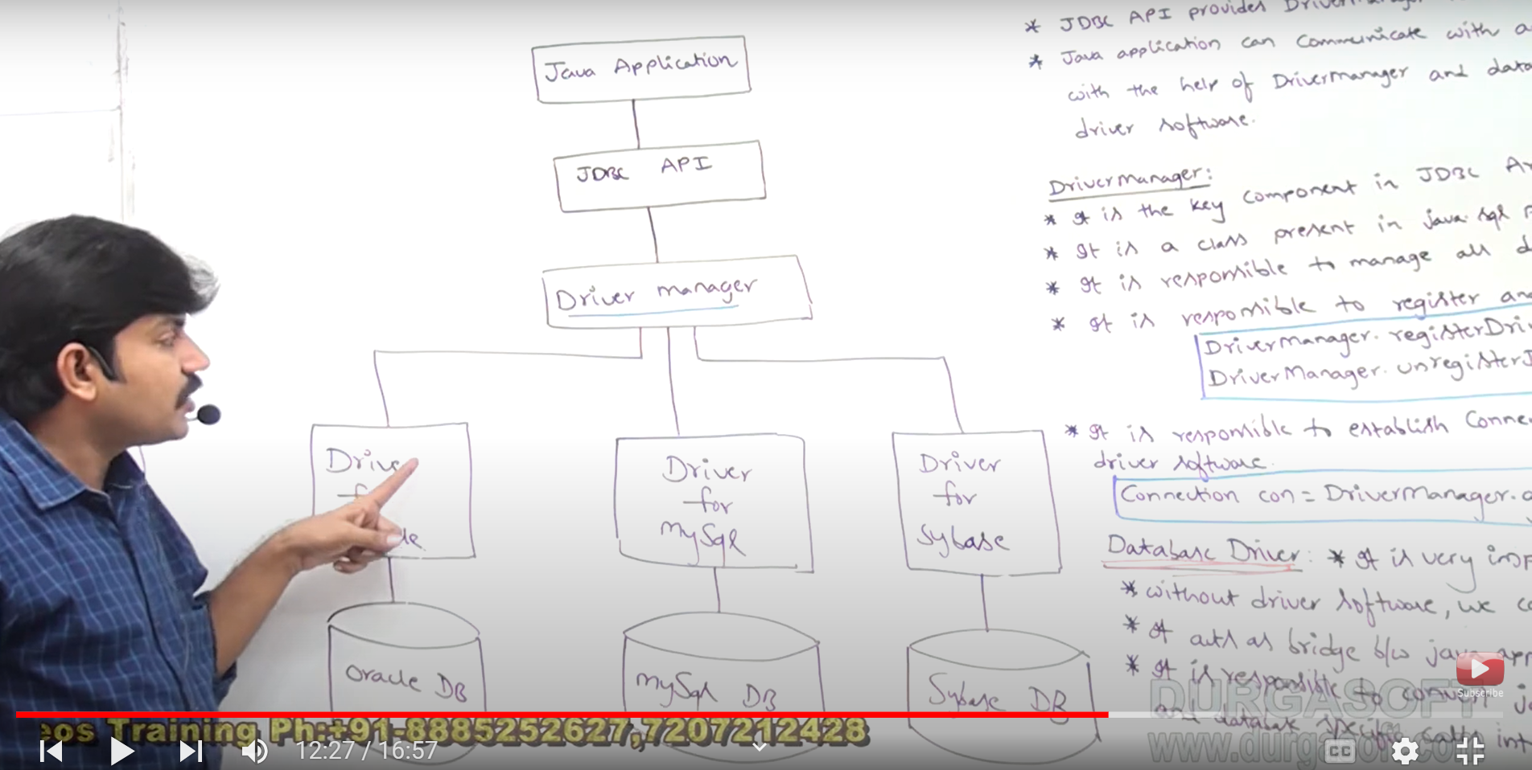

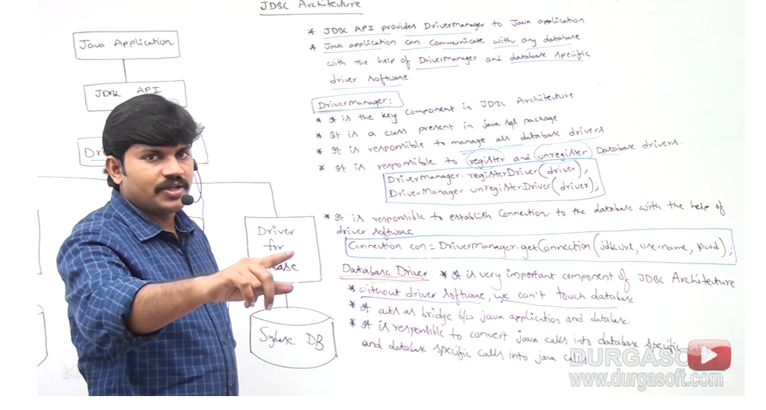

Java is platform independent  
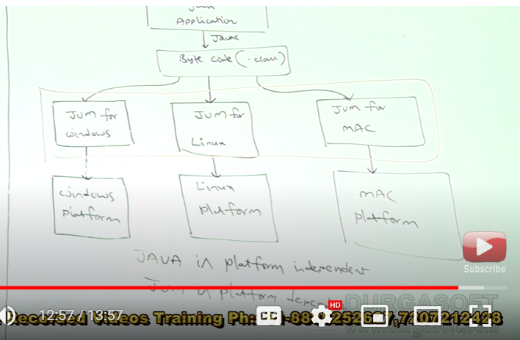

jDBC is platform independent

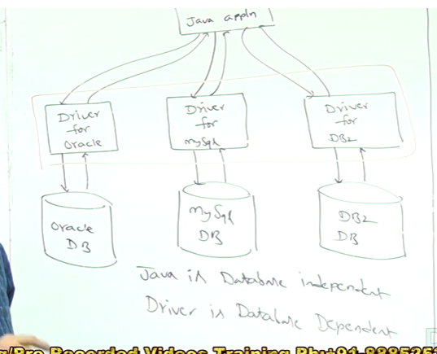

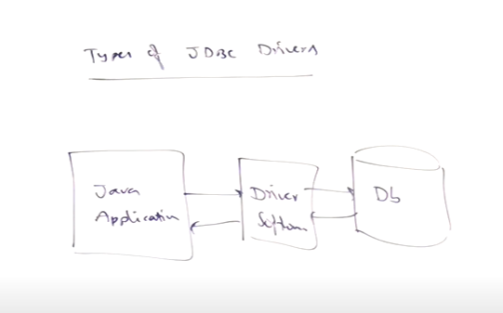

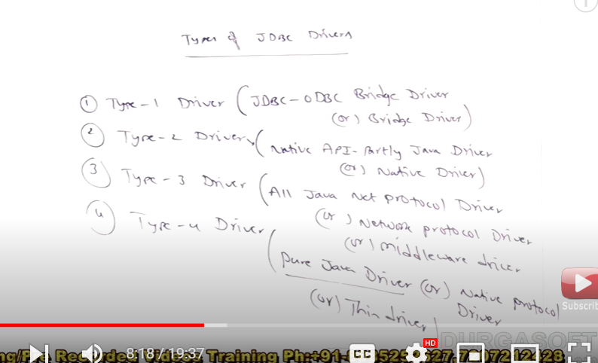

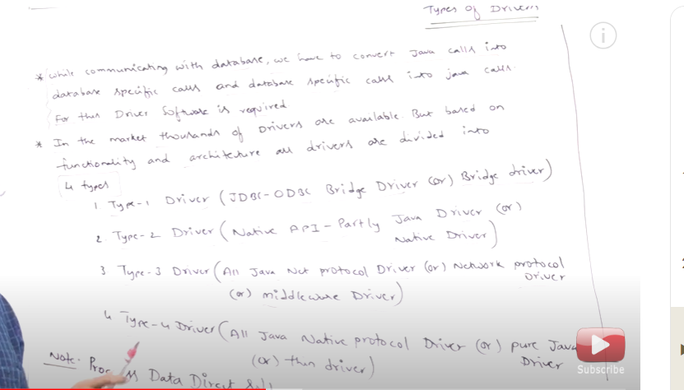

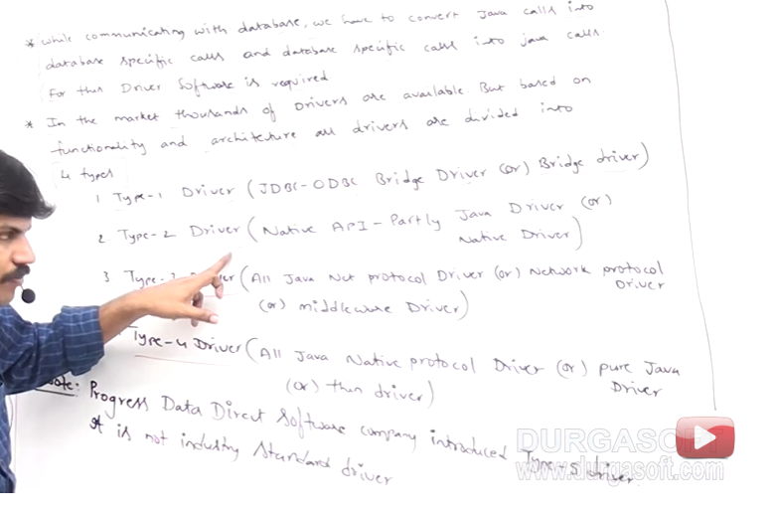

When to use which driver to use?

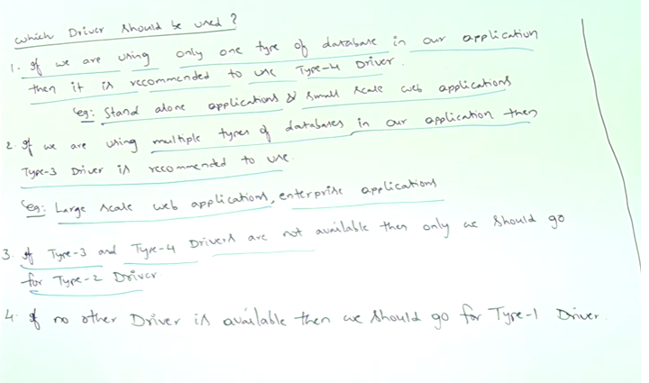

In our project if we're using only one database we will go with the type 4

Because type four is platform independent and only one database driver and it for comments also increases you the first standalone application and small scale application

In your application there are a number of databases we need to use we'll go with the type 3 driver because type 3 driver is database independent

type 3 used for large scale web applications on the enterprise applications

type 2 used if there is no type three type 4 driver are present

type 1 used if there is no type 4 type three type 2 drivers are present.

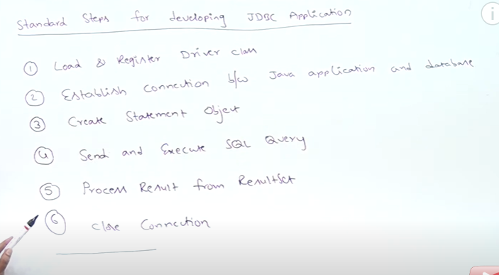

**Statements in JDBC**

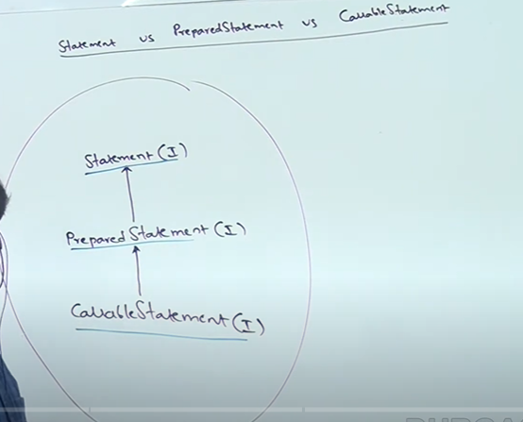

**Statemets:**

**You can create a statement object like**

**Statemt st= con.createStatement();**

**What advantage of statement object can you use multiple SQL statements for one single statement object**

**If you're executing same query /statement and multiple times it will compile and execute multiple times so it will decrease the performance of applications.**

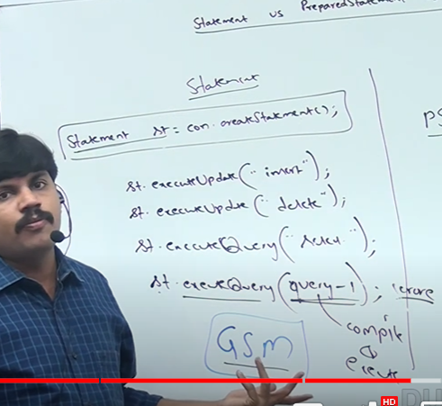

**disadvantages please in statement object every SQL statement will compile at every time for suppose we want to execute single SQL statement in 1000 times it will compile 1000 times and then it will run so it will decrease the performance of the applications.**

**Preparedstatement:**

**In prepared statement the query compiles once and execute multiple times so it will increase the performance of the application.**

**But prepared statement can accept only one query or statement at that time**

**if you want to execute multiple statements or multiples queries we need to create multiple prepared statements this is the drawback of prepared statement .**

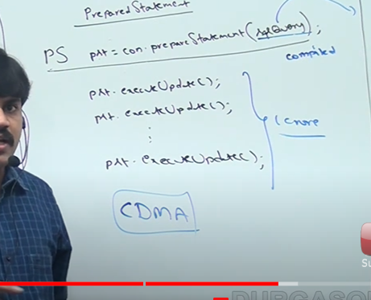

**CallableStatemts:**

**Callable statement is used to to call stored procedure/functions to JDBC application.**

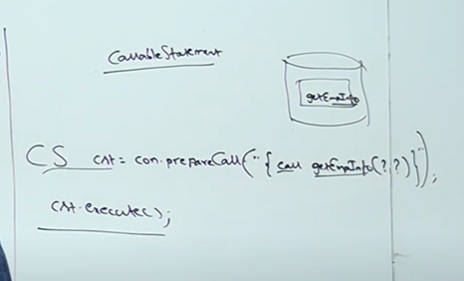

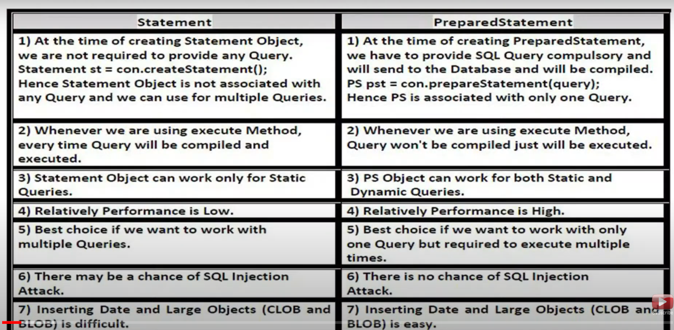

**Batch Update: to group all sql queryies into single batch and send that batch db at once .  
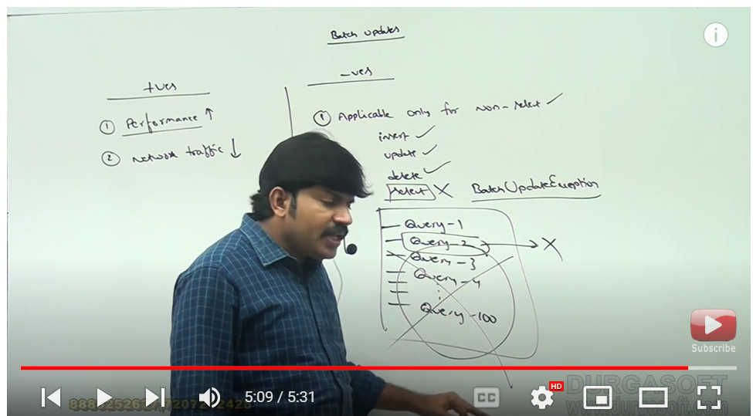**

**JDBC execute methods:**

**There 4 different types of exe**cute methods present in JDBC.

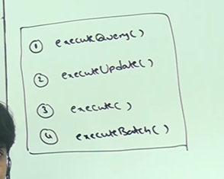

**exeutequery(): used to execute select query statemets**

**Ex: select * from student ;**

**Return type is ResultSet Interface.**

**Resultset rs= st.executeQuery(“select * from employee”);**

**executeUpadte(): used to execute non-select queries(insert, update , delete) .**

**return type is integer value.**

**Int upadteCount= st.executeUpadte(“insert/update/delete”);**

**execute(): it is used if you don’t know the query type (wheather it is select or non-select query/statement) that time we will use execute() method.**

**So it will work for both queries(select/non-select) statements.**

**Return type Is boolen type.**

**boolean b= st.execute(“select/non-select”);**

**to call stored procedure also with help of execute() query.**



**excuteBatch(): it is used to execute group of sql queries .**

**st.executeBatch();**

**performance is increasesd**

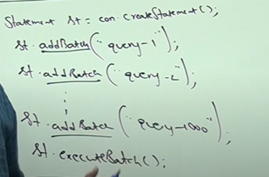

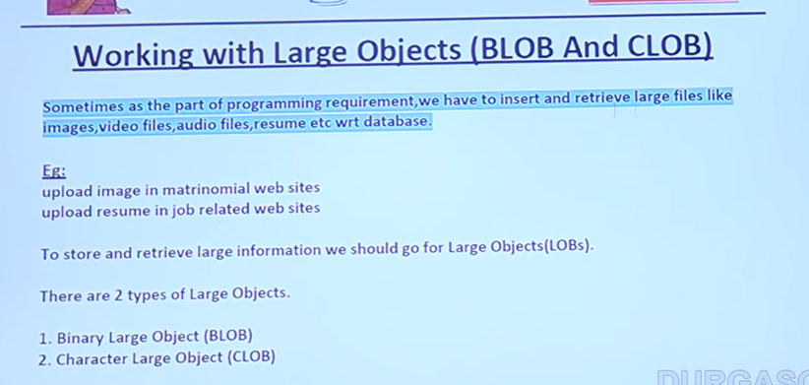

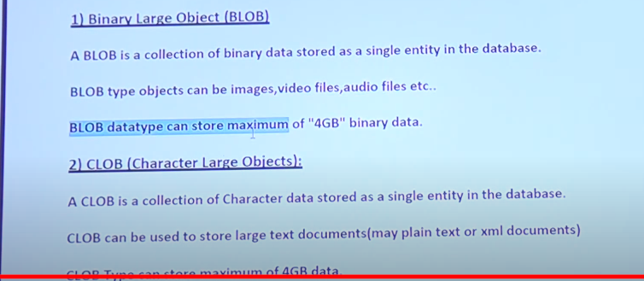

**Large objects in JDBC= used to store Large objects ( images, videos , audio files in DB we will use LOB’s)**

**LOB’s**

* **BLOB(Binary Large object)(4 GB limit it’s size)( images, videos , audio files in DB)**
* **CLOB(Character Large object)(used to store .txt files and .xml files, example resume.txt.)(4 GB size)**